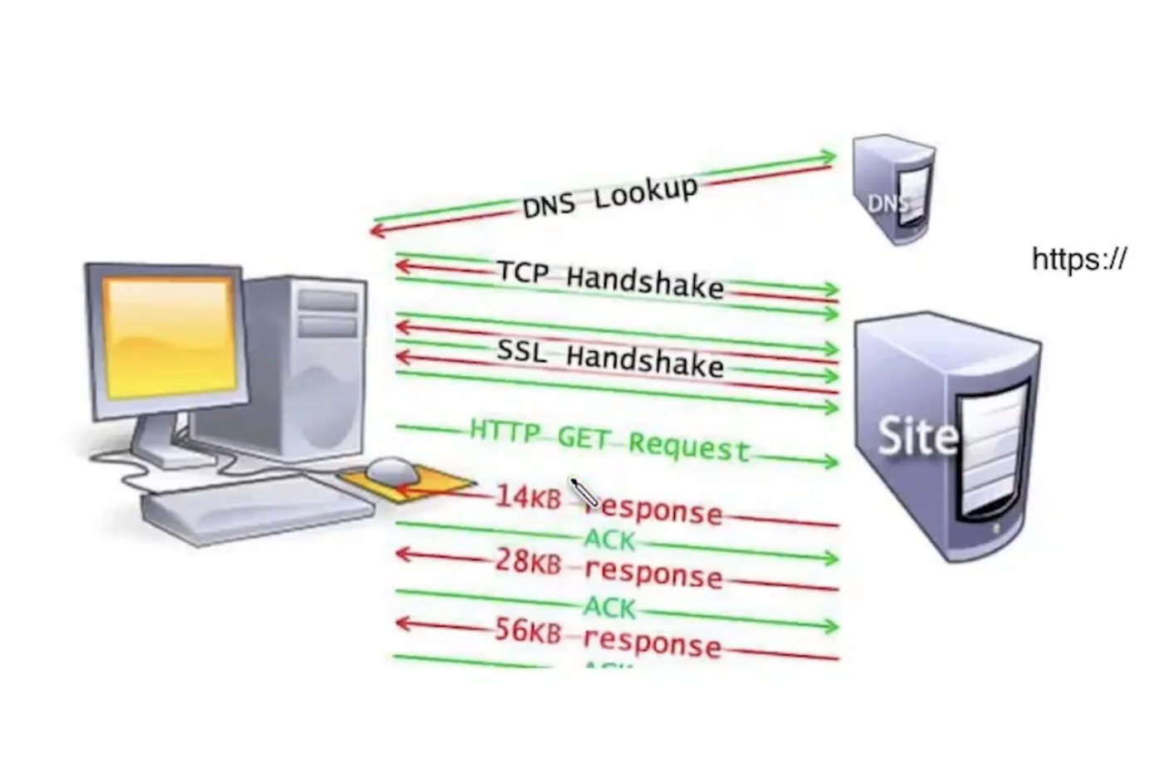

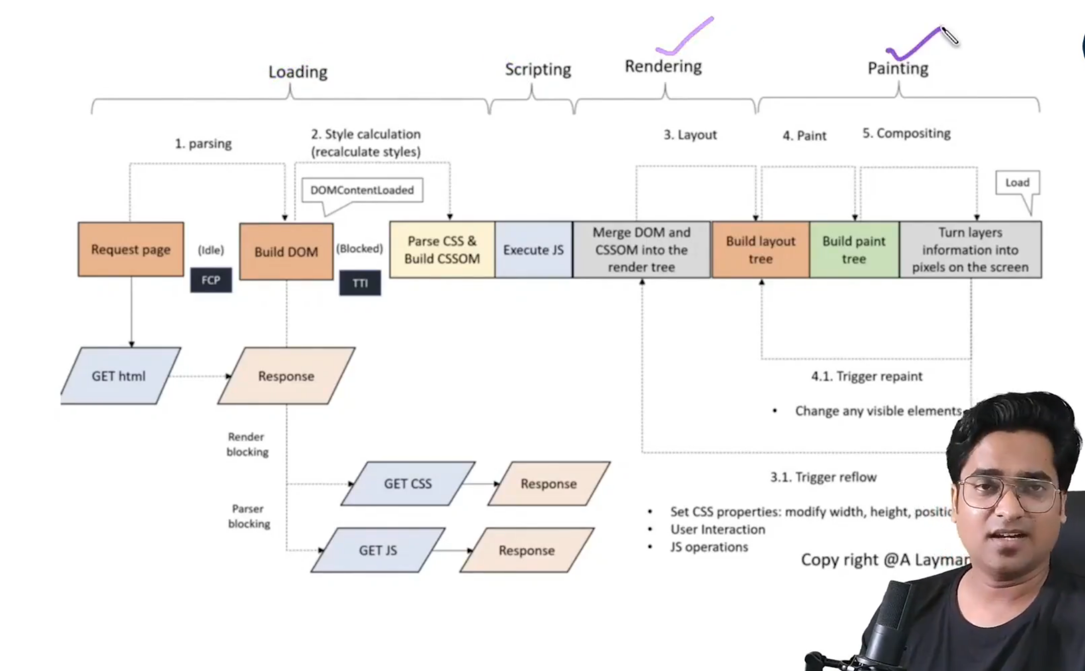

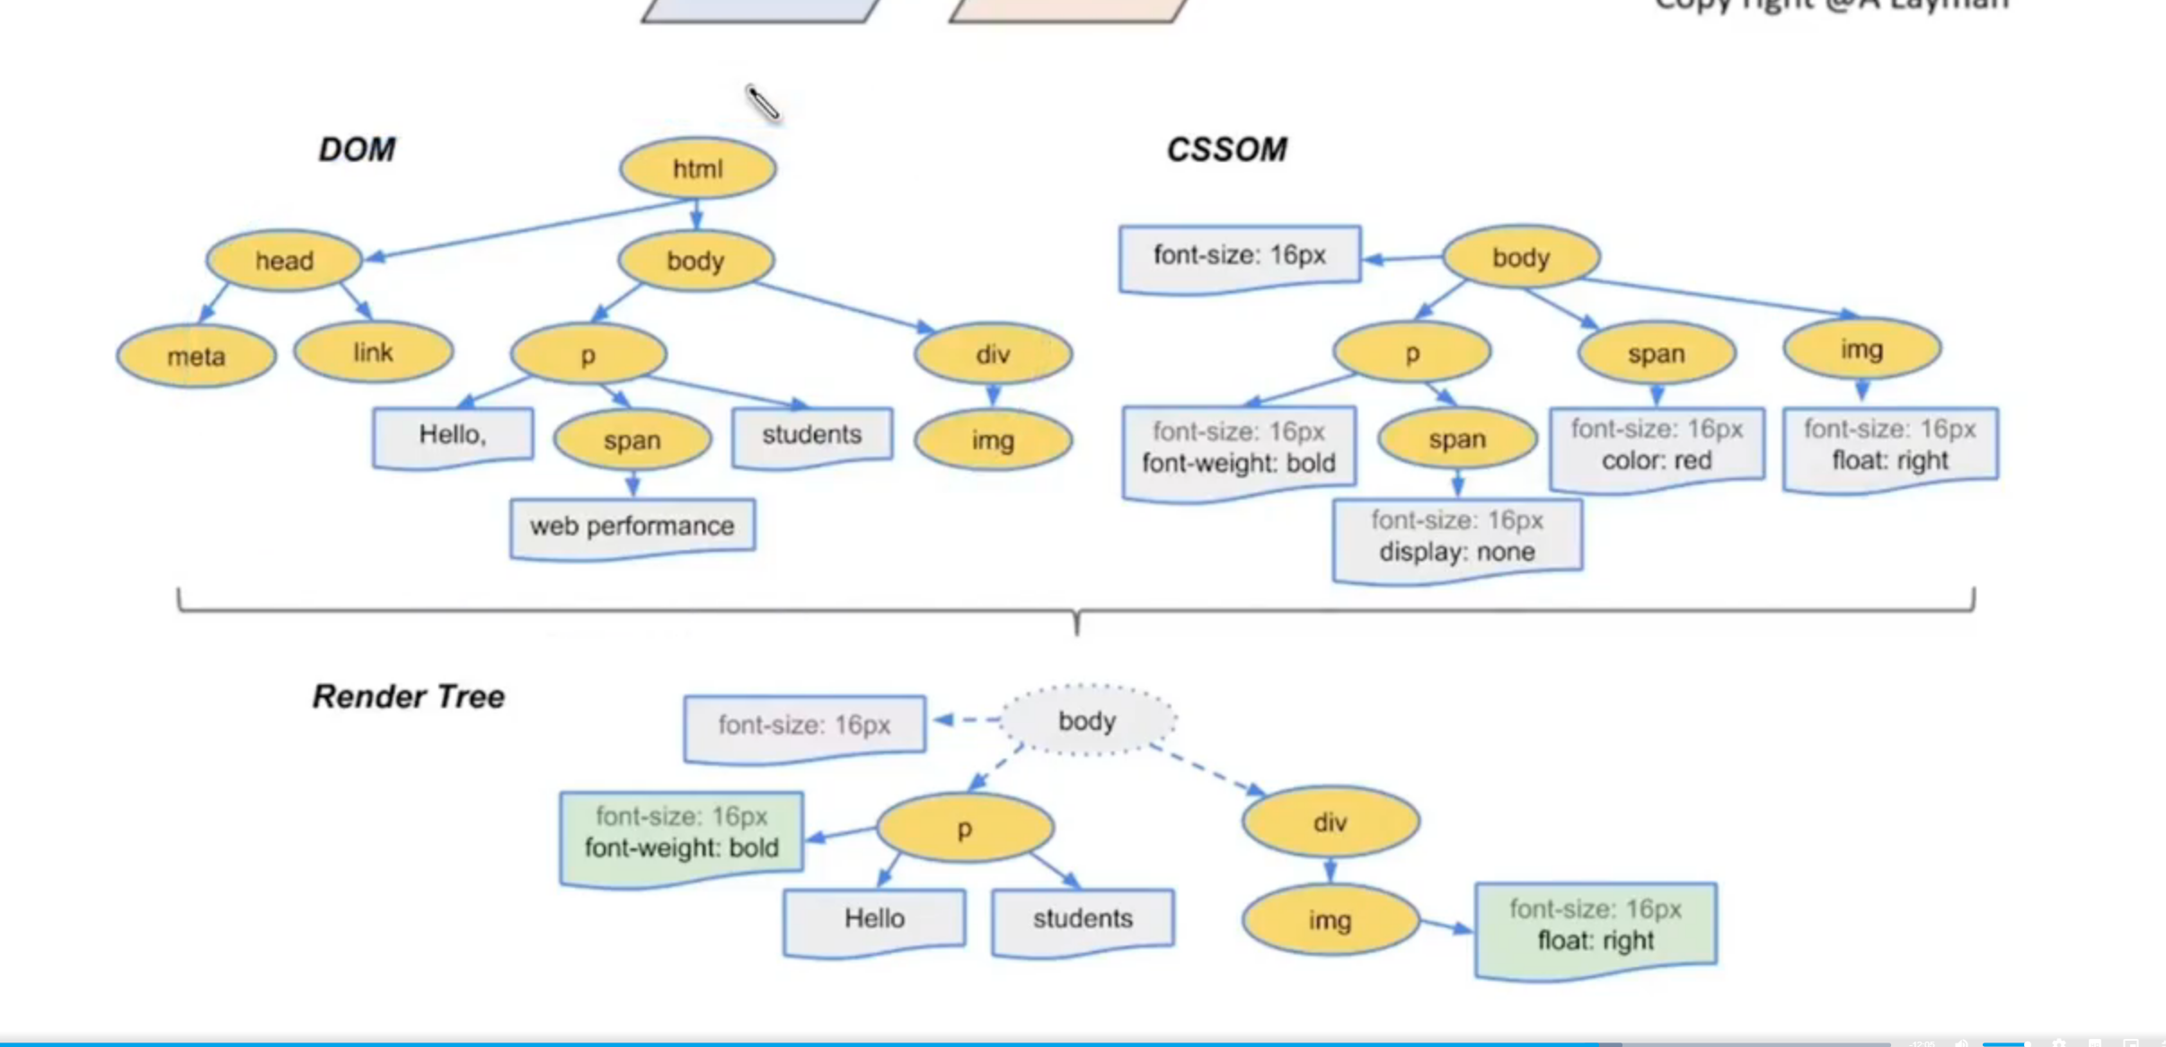

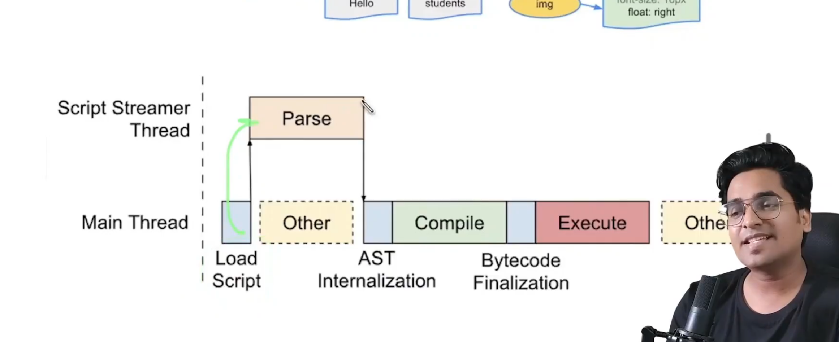

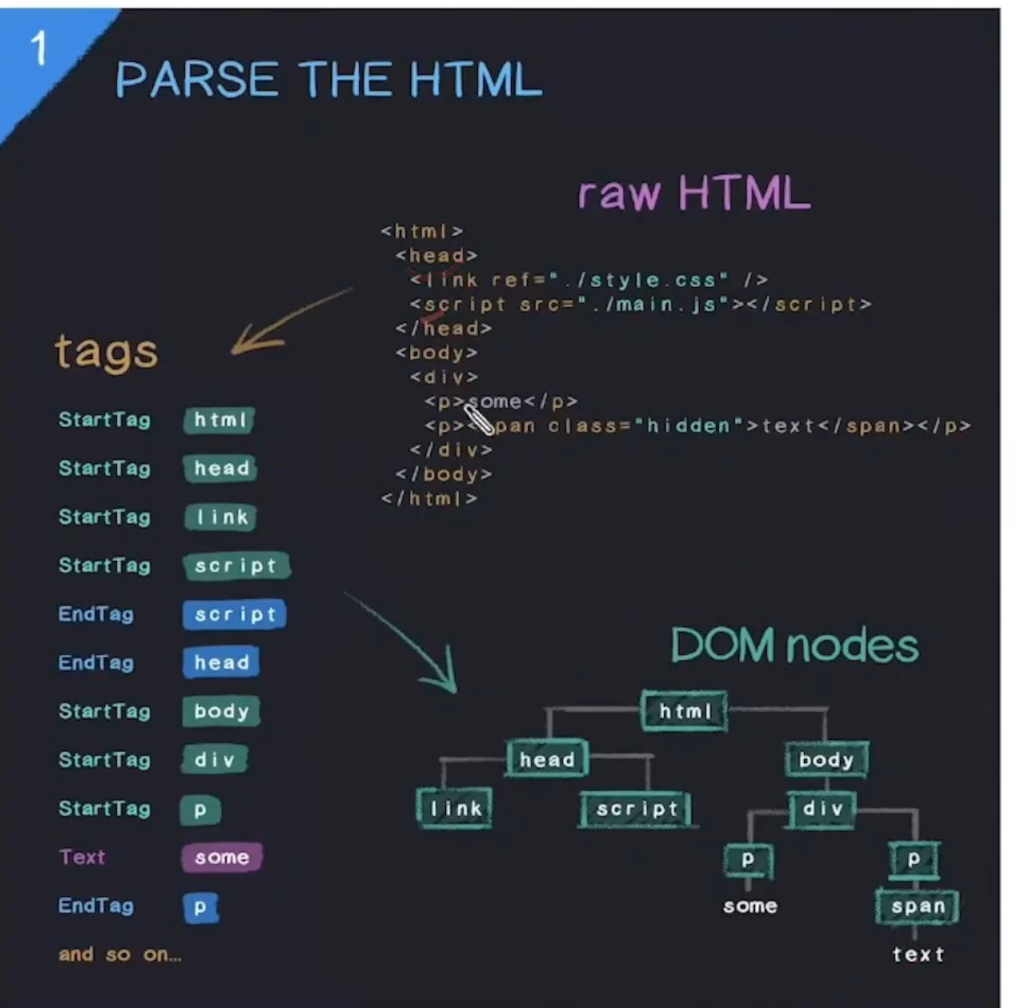

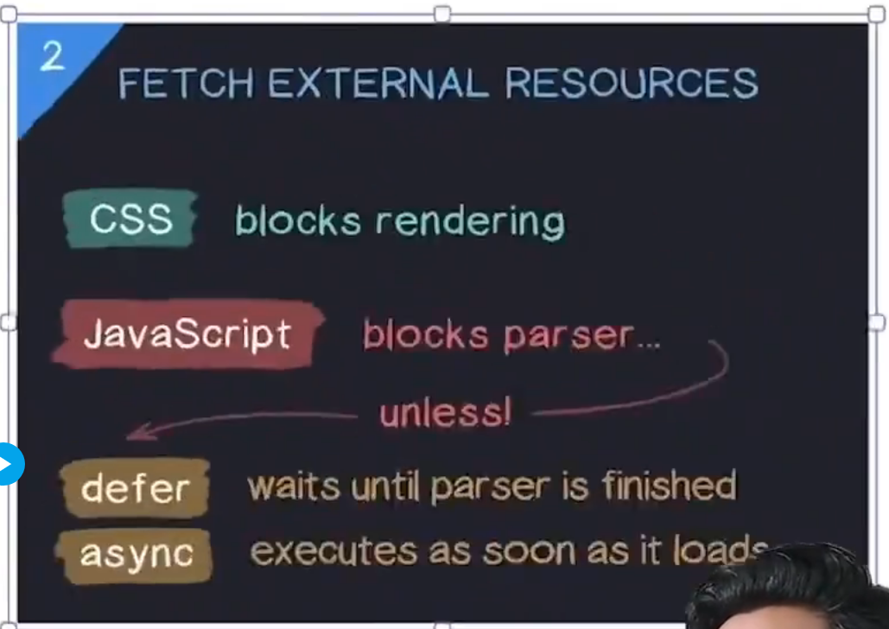

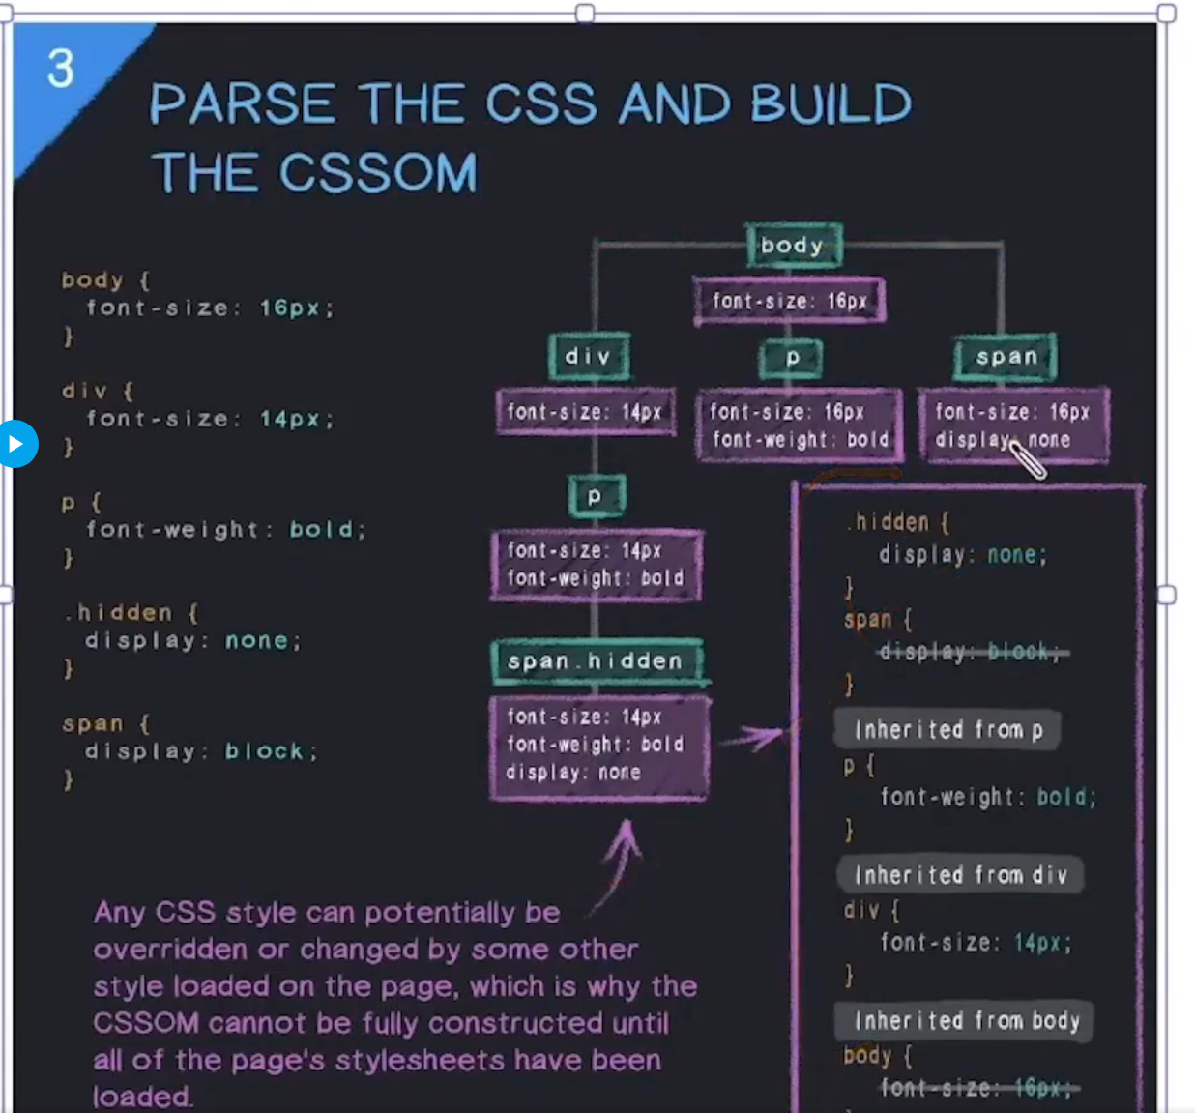

* CSS is render blocking, JS is parser blocking (it will block parsing of html).

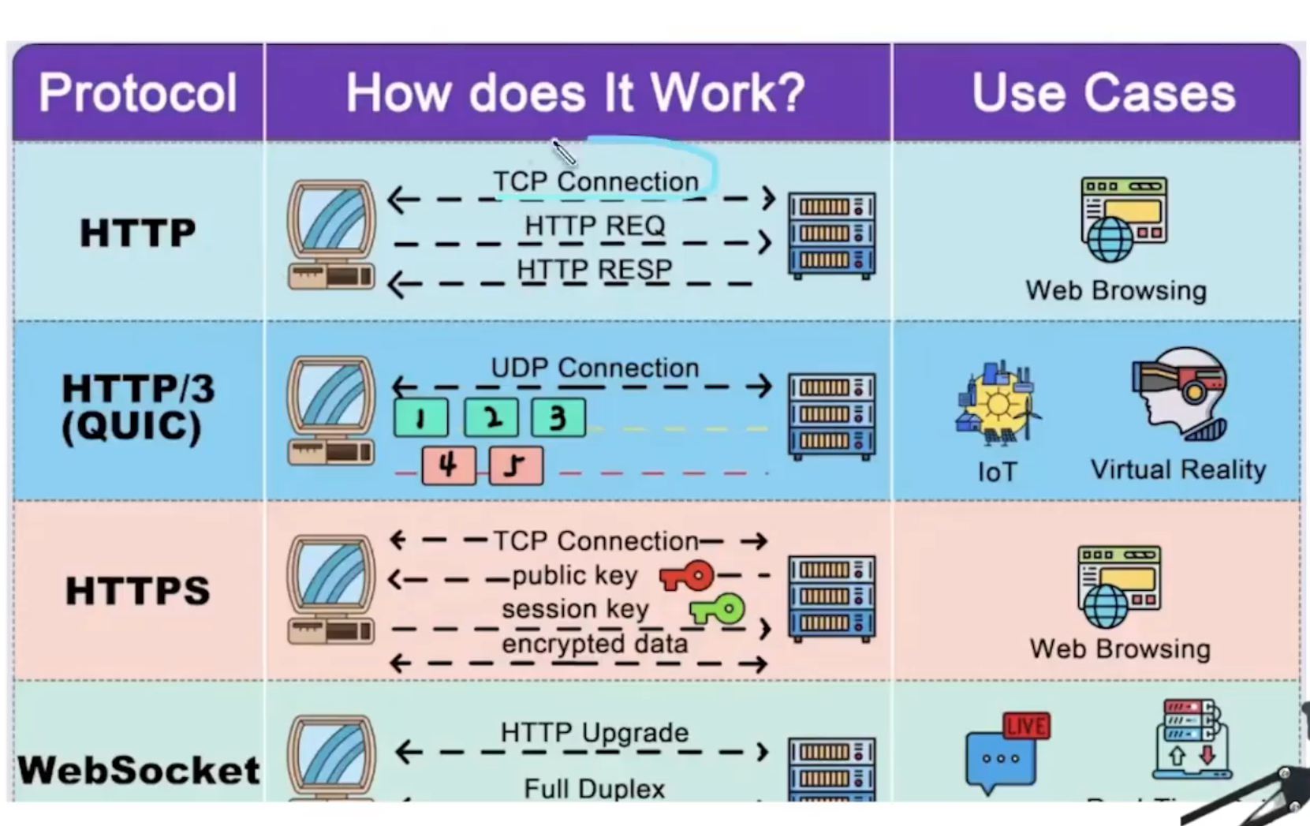

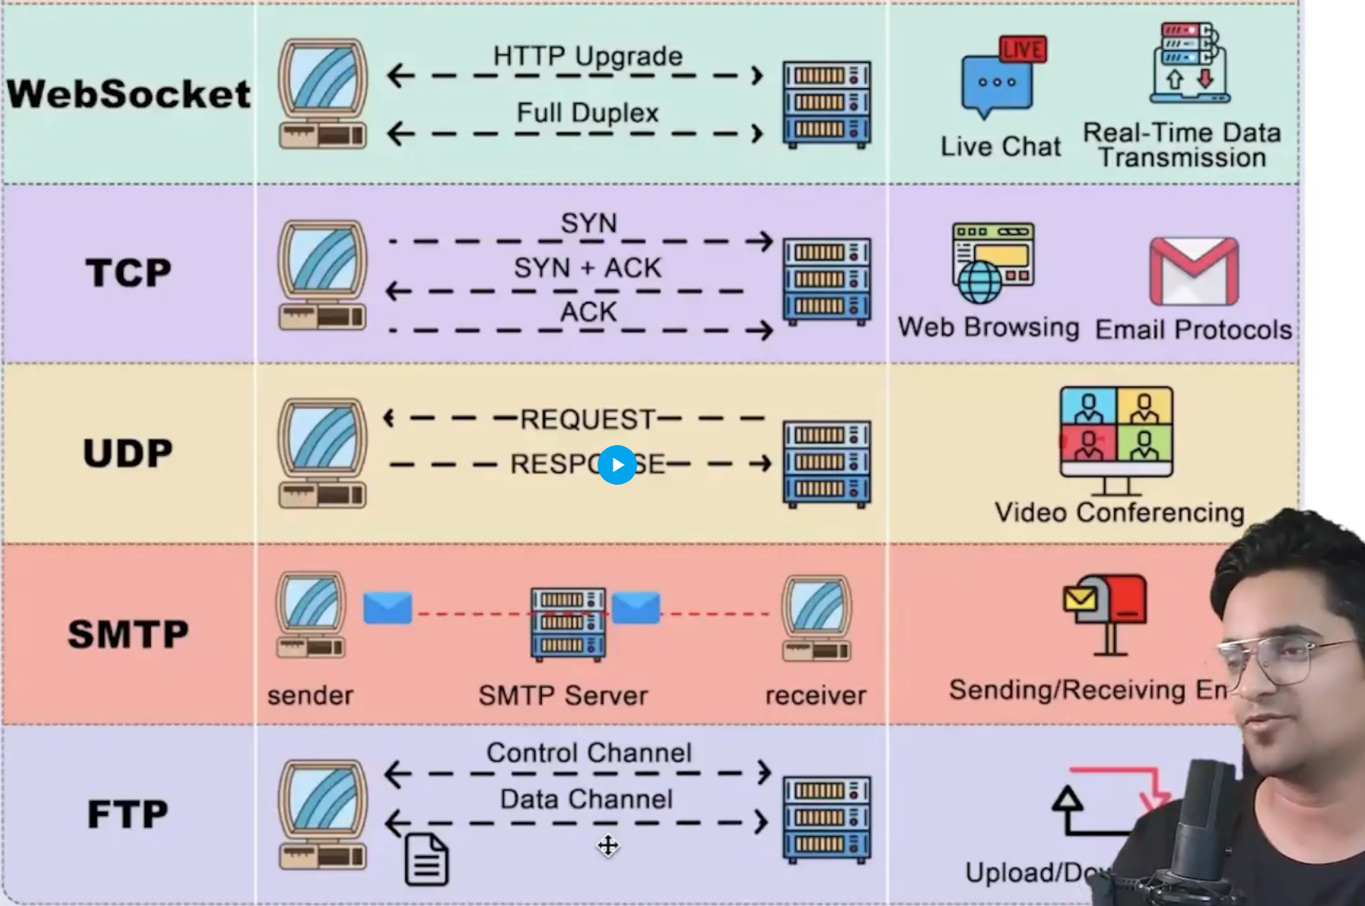

Here's a comprehensive comparison table of all HTTP versions: HTTP/1.0, HTTP/1.1, HTTP/2, and HTTP/3.

| **Feature** | **HTTP/1.0** | **HTTP/1.1** | **HTTP/2** | **HTTP/3** |
| --- | --- | --- | --- | --- |
| **Year Released** | 1996 | 1997 | 2015 | 2020 |
| **Protocol Type** | Text-based | Text-based | Binary-based | Binary-based |
| **Underlying Transport** | TCP | TCP | TCP | **QUIC** (over UDP) |
| **Connection Handling** | One request per connection | Persistent connections (Keep-Alive) | Multiplexing over a single connection | Multiplexing over a single connection |
| **Head-of-Line Blocking** | Severe | Severe | Reduced (at HTTP level but not at TCP level) | Eliminated (even at the transport level) |
| **Request Multiplexing** | No | No | Yes (on a single connection) | Yes (on a single connection) |
| **Header Compression** | No | No | Yes (HPACK compression) | Yes (QPACK compression) |
| **Server Push** | No | No | Yes | Yes |
| **Encryption** | No | Optional (via TLS/SSL) | Optional (but typically used with TLS) | **Mandatory** (via built-in TLS 1.3) |
| **Connection Establishment** | Slow (new TCP connection for each req) | Faster (persistent connections, Keep-Alive) | Faster (persistent connections) | **Very fast** (QUIC handshake with TLS) |
| **Latency** | High | Improved with Keep-Alive | Lower than HTTP/1.1 (multiplexing reduces RTT) | **Lowest** (multiplexing + 0-RTT QUIC setup) |
| **Compression** | No | Body compression (gzip, deflate) | Body + Header compression | Body + Header compression |
| **Connection Reuse** | No | Yes (with Keep-Alive) | Yes | Yes |
| **Stream Prioritization** | No | No | Yes | Yes |
| **Connection Migration** | No | No | No | **Yes** (can migrate across networks) |
| **Packet Loss Handling** | TCP-based recovery (slow) | TCP-based recovery | TCP-based recovery | **QUIC-based recovery** (faster and efficient) |
| **Supported Encryption Protocols** | SSL/TLS | SSL/TLS | TLS 1.2, TLS 1.3 | **TLS 1.3 only** |
| **Efficiency** | Low (one request per connection) | Improved (Keep-Alive) | High (multiplexing, header compression) | **Highest** (multiplexing, no head-of-line blocking) |
| **Typical Use Cases** | Basic web pages, older applications | Most websites, general web usage | High-traffic sites, modern web applications | Future of the web, real-time and mobile applications |

**Key Differences Summarized:**

1. **HTTP/1.0**: Basic, no persistent connections, each resource required a new connection.
2. **HTTP/1.1**: Introduced Keep-Alive, allowing persistent connections and chunked transfers; reduced the overhead of connection creation but still suffers from head-of-line blocking.
3. **HTTP/2**: Major performance improvements with multiplexing, header compression, and server push; however, head-of-line blocking at the TCP level still exists.
4. **HTTP/3**: Built on QUIC over UDP, HTTP/3 eliminates head-of-line blocking entirely and drastically reduces latency, especially in lossy network conditions. It also introduces faster connection establishment and mandatory encryption.

HTTP/3 is the most advanced, optimized for modern web usage, including mobile devices and real-time applications.

4o